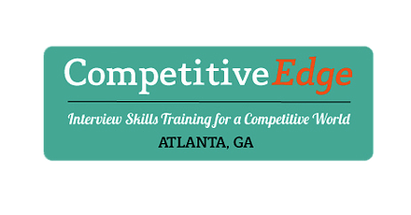

Questions to Ask during College visits and/or college interviews

Academics and faculty
■ What is distinctive about education here? What is the educational philosophy of the
college? Has it changed much in recent years?

■ What is the most popular major on campus? Why?
■ Do you think that students are generally enthusiastic about their classes? Do people talk
about their courses outside of class?

■ How would you characterize the academic pressure and workload?
■ Are there research possibilities with the faculty? In what areas?
■ What are the strengths and weaknesses of the advising system?
■ What is the quality of student and faculty relationships? Is the faculty interested in and
accessible to students after class? Do faculty members participate in student activities?

■ Are curriculum changes in the works? How will that affect my college years?
■ Are any departments being cut back or discontinued? If so, why?
■ Are any new programs scheduled for the next four years?
Students
■ How would you characterize the majority of students?
■ From what economic background are the majority of students?
■ Are there clubs, activities, or housing that are minority related?
■ What do students like most about the college? Like least?
■ Has the student government made any real contribution to the school? How do you get
into student government?

■ What political, social, or academic issues concerned students last year? How did the
administration react? What was the resolution?

Social life and campus activities
■ What do students do for fun?
■ What is the role of fraternities and sororities on campus? If I didn’t want to join, could I
have a satisfactory social life?

■ What are the dominant social groups on campus? Do the groups get along with one
another? Have there been any problems?

■ What role do team sports play in the social life of the college? What happens on football or
basketball weekends? If I didn’t want to join in, would I find kindred spirits?

■ Is there a good balance of academics, social life, and extracurricular activities?
■ What were the social or cultural highlights last year?
■ What is the role of the campus newspaper?
■ Is there an alcohol problem and, if so, how is the college handling it? What is the incidence
of binge drinking? Do students feel safe on campus?

Campus facilities
Housing and dining
— Is there something I should know about housing that would help me in my choice, eventually?
Activity centers and athletic and recreational facilities
— What kinds of facilities does the student center have? Is it a magnet for student
activities? Are there other hangouts?

— is there a fitness center?
Career Counseling
— at what point may a student begin using the career counseling office?
-- does the career counseling office assist with internships?
--is the career counseling office available to students even after graduation?
Library
— What have been students’ experiences with the library? Are there extended hours during exams and plenty of places to work?
— Is the library well equipped with computers and copy machines?
The community off campus
■ What is there to do in town? How would I get there?

